**Lab 3: Limiting and Clamping Circuits (2% of total)**

**Objective:**

To analyze, simulate, build and test diode base clipping and clamping circuits.

**Equipment and Components:**

* Breadboard, Function generator, Oscilloscope, Multimeter
* Diodes (1N4003)
* Zener diodes
* Resistors (1kΩ, 10kΩ, 100kΩ)
* Capacitors (47uF)

**Pre-Lab:**

*Limiter (Clipper): The purpose of a limiter (or clipper) is to shape an input waveform and clip or cut off its top half, bottom half or both halves together.*

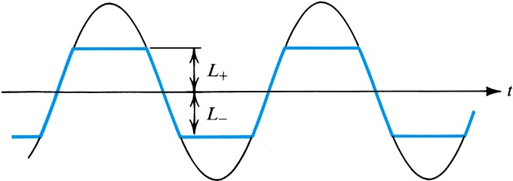

**Fig. 1 Purpose of a Clipper Circuit**

*Clamper: The purpose of a clamper is to change the DC level of a signal to a desired DC value.*

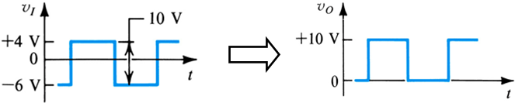

**Fig. 2 Purpose of a Clamper Circuit**

1. Read section 4.6 of Sedra/Smith and understand how clipping and clamping circuits work.
2. Simulate the following circuits (Fig. 3.1, 3.2, 3.3, and 3.4) using a SPICE simulator:

**Part 1: Diode Limiter (Fig. 3.1)**

1. Use D1, D2 = 1N4003 (or similar), R = 1 kΩ.
2. For input voltage, use a sinusoid with 5Vpp, 100Hz and no DC component.

***Note:*** *Use small time steps for finer resolution. Note the highest and lowest voltage values. Note how abruptly the diodes cut off the input waveform. This is known as hard-limiting. Try playing with the input voltage amplitude, input voltage frequency and resistor values. For frequencies, try 100 Hz, 1kHz, 10kHz, 100 kHz, 1MHz, 10MHz. How does the output change?*

1. Record the plot of VI vs time and VO vs time. What are the highest and lowest voltage values? Why do we get these values?
2. Record the plot of VO vs VI ; use frequency=100 Hz, amp=2.5V
3. What happens to the waveform if you change the resistor value or input voltage amplitude or the input voltage frequency?
4. Keep D1 and Remove D2 from the circuit and simulate. What is the result? Next, keep D2 and remove D1 from the circuit and simulate. What is the result?

**Part 2: Zener Diode Limiter (Fig. 3.2)**

1. Use Z1, Z2 = 1N4733A (or similar) zener diodes, R= 1 kΩ.
2. For input voltage, use a sinusoid with 14Vpp, 100Hz and no DC component.

***Note:*** *In the simulator, you will need to replace the generic zener with a zener that has low breakdown voltage (In the experiment, we will use the zener- 1N4733A that has breakdown rating of 5.1 V). Pick the one with breakdown rating closest to 5.1 V. Note how the circuit cuts off the input waveform gradually. This is known as soft-limiting.*

1. Note the min and max values of the output voltage.
2. Increase and decrease the resistor value. Note the change in the output voltage. Where is it smoothest?
3. Record the plot of Vin and Vout vs time.
4. Record the plot of Vout vs Vin.

**Part 3: Clamper (Fig. 3.3)**

1. Use D1= 1N4003 (or similar), R= 10 kΩ, C = 47 *μ*F,
2. For input voltage, use a **square wave** with 2 Vpp, 100 Hz, DC=0 V.

***Hint:***

* 1. *Time period = 1/frequency.*
  2. *In order to generate a square wave you want the pulse to be ON and OFF for equal amounts of time.*

***Note:*** *Larger the capacitor, better the shape of the output voltage.*

1. Note the min and max values of the output voltage.
2. Record the plot of Vin and Vout vs time.

**Part 3: Voltage doubler (Fig. 3.4)**

1. Use D1, D2 = 1N4003 (or similar), R = 100 kΩ, C1 ,C2 = 47 *μ*F,
2. For input voltage, use a sinusoid with 5Vpp, 100Hz and no DC component.
   1. *Note how a voltage doubler (and hence multiplier) can take AC voltage, and multiply that voltage by some factor giving a larger DC voltage (the output voltage should be 2 diode drops lower than twice the peak input voltage). Probe/Measure the voltage across D1. Note the peak value. Now probe/measure the output voltage.*
3. Note the min and max values of the output voltage.
4. Record the plot of Vin and Vout vs time.

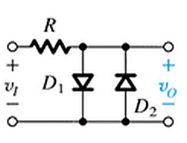 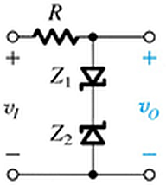

Fig. 3.1 Diode Limiter Fig. 3.2 Zener Diode Limiter

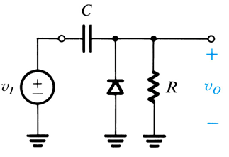 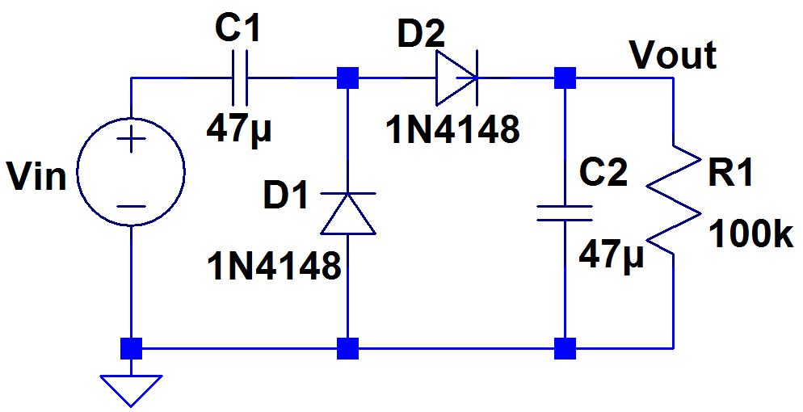

Fig. 3.3 Clamping circuit Fig. 3.4 Voltage doubler

**Procedure:**

1. Build the simulated circuits on a breadboard.
2. Record the oscilloscope plot of Vin and Vout vs time, for each of the circuit.
3. Record the highest and lowest output voltage values. How does they compare to the simulated value?
4. For circuits in Part 1 & 2, use the oscilloscopes XY mode and record the Vout vs. Vin plot.

*Get the recorded outputs in your lab report checked off by the instructor.*

**Conclusion:**

1. For the diode limiter circuit, how would you change the limiting voltage to approximately +1.4V and -1.4V?
2. Can you think of an application for each of the circuits?